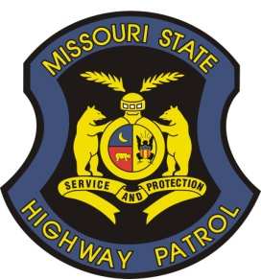
MISSOURI STATE HIGHWAY PATROL
2012 NATIONAL HOMICIDE SEMINAR
October 21-25, 2012

R E G I S T R A T I O N F O R M

ATTENDEE INFORMATION

FULL NAME AND RANK:

NAME AS YOU WOULD LIKE IT TO APPEAR ON NAMETAG:

AGENCY:

ADDRESS: Email:

TELEPHONE: FAX:
WILL YOUR SPOUSE BE ACCOMPANYING YOU?

SPOUSE’S NAME:
ATTENDEE REGISTRATION FEE $395 SPOUSE REGISTRATION FEE $90

THE MAXIMUM NUMBER OF SPOUSES FOR THE SPOUSES PROGRAM IS 30 (FIRST-COME, FIRST-SERVE BASIS)

MAKE CHECK PAYABLE TO:
MISSOURI STATE TROOPERS' ASSOCIATION Tax ID # 43-1253773

PLEASE ENCLOSE CHECK, 2 BUSINESS CARDS (per attendee), AND 1 AGENCY SHOULDER PATCH (per agency)

To Make Lodging Reservations, Please Call: 888-627-8538
Be Sure to Tell the Hotel You Will Be Attending the Missouri State Highway Patrol Homicide Seminar
OR register on line at:
https://www.starwoodmeeting.com/StarGroupsWeb/res?id=1202104030&key=2FACA

I have made lodging reservations with the Westin Crown Center Confirmation #
I have not made lodging reservations at this time
I will not require lodging

REGISTRATION FORM AND FEE(S) MUST BE RECEIVED BEFORE August 1, 2012

SEND FORM TO:
For DDCC Use Only
Invoice #__________
Date _____________
Receipt # _________
Date _____________
MISSOURI STATE HIGHWAY PATROL
DIVISION OF DRUG AND CRIME CONTROL
POST OFFICE BOX 568
JEFFERSON CITY, MO 65102
573-751-3452 FAX 573-526-5577
Form can also be emailed to: ddccmail@mshp.dps.mo.gov

